Setting Up a Server on Windows with XAMPP
This document is obsolete. As of DerbyNet v2.0, the recommended set-up on Windows is to use the .win.zip file, which includes a bespoke Uniform Server to host DerbyNet. The process described in this document, while still correct, involves significantly more steps. See the document Installation- Windows for the currently-recommended installation process.
DerbyNet can be installed alongside Grand Prix Race Manager to provide added functionality, while leaving the actual running of the derby to GPRM. (Note that DerbyNet is neither endorsed nor supported by Lisano Enterprises, LLC, the makers of GrandPrix Race Manager.)
DerbyNet depends on a web server platform with PHP and access to a database. This document describes setting up these underlying technologies on Windows using the XAMPP installer.
(Of course, there are other options available, but they're outside the scope of this document.)

Install the XAMPP Stack

Download and Install the XAMPP Stack
XAMPP (Cross-platform, Apache, MySQL, PHP, and Perl) is a free, convenient server stack with a single-step install. Download the current version at:
https://www.apachefriends.org/download.html
(Note the warning that Windows XP and Windows 2003 require a different version, available at http://sourceforge.net/projects/xampp/files/XAMPP%20Windows/1.8.2/xampp-portable-win32-1.8.2-6-VC9.zip/download.)
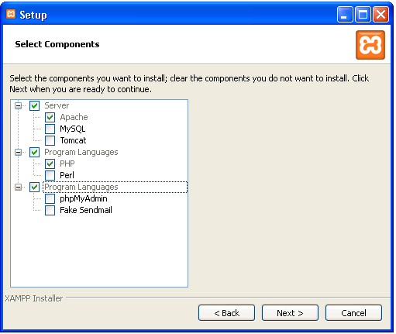
After downloading, follow the instructions in the installer. The only elements of the stack that you'll need are Apache and PHP; you can de-select all the others to save space, and reduce any chance of conflict. For everything else, choose the default options unless you have a particular reason to decide otherwise.
By default, the installer will place everything it installs in the folder C:\xampp. (If you choose a different installation location, modify the remaining instructions in this document appropriately.)

Activate the ODBC Driver
Once the XAMPP installer finishes, we need to make a small change to the PHP configuration file. Use Notepad or another text editor to open the file C:\xampp\php\php.ini. Locate the line that says:
;extension=php_pdo_odbc.dll
and just delete the semicolon. Remember to save the file.

Start or Restart the Apache Server
If you haven't already, launch the XAMPP Control Panel (either through the Start menu, or at C:\xampp\xampp-control.exe). Stop the Apache server (if it's running), then (re)start it. This is necessary for the change to the php.ini file to take effect.

Install DerbyNet Files

Download and Unzip
Download and unzip the DerbyNet distribution.

Move Web Site Files
Locate the folder named website, and move or copy all the files in that folder to the C:\xampp\htdocs folder.

Create a Local Subdirectory
Create a "local" subdirectory, C:\xampp\htdocs\local, if one doesn't already exist.

Confirm Successful Installation
Open a browser and point it to http://localhost/. This should take you to the DerbyNet set-up page. Continue by following the instructions in the “After Installation – Windows GPRM” guide.

Congratulations!
You've finished the hard part.

